WM - III Case Study

Student Name: ­­­­­­­­­­­­­­­­­­­­­­­­­­Addison Babcock User ID (GBI-###) GBI-036

Date: 11/22/2016

|  |  |
| --- | --- |
| **Description** | **Your Data** |
| Standard [sales] Order # (p4) | 61 |
| Outbound Delivery document # (p8) | 80000059 |
| Transfer order # (p12) | 0000002062 |
|  |  |

Replace the image shown below with an image from your work. (Use the Snipit tool). The image should only be of the data i.e., not a full screen shot.

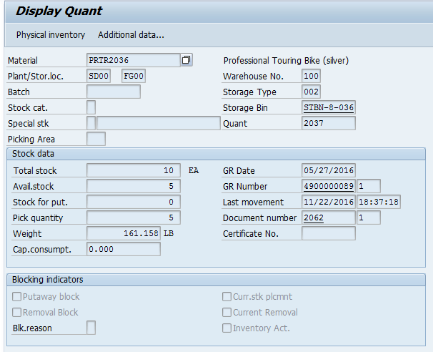

I missed capturing this next screenshot. 